**Task23- SQL Workbench Screenshots**

**Question1:**

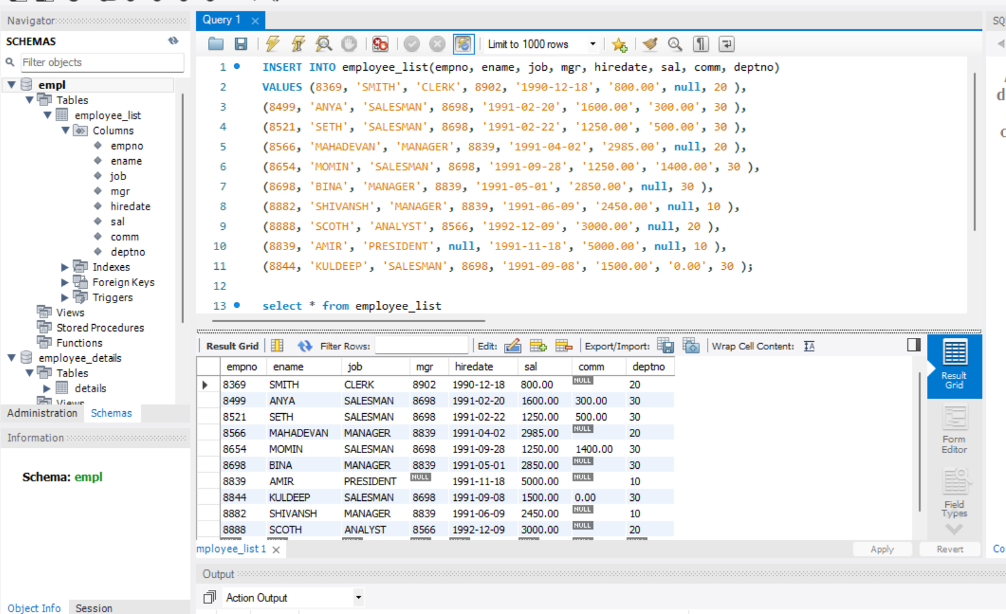

**Q1.A) Write a query to display E Name and Sal of employees whose salary are greater than or equal to 2200:**

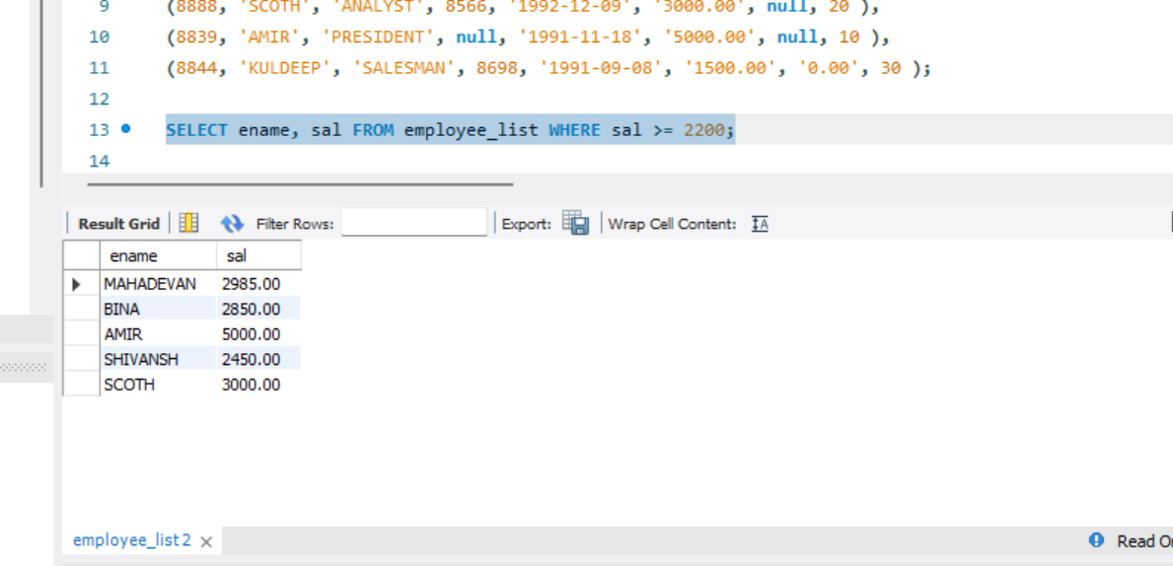

**Q1.B) Write a query to display details of employee who are not getting commission:**

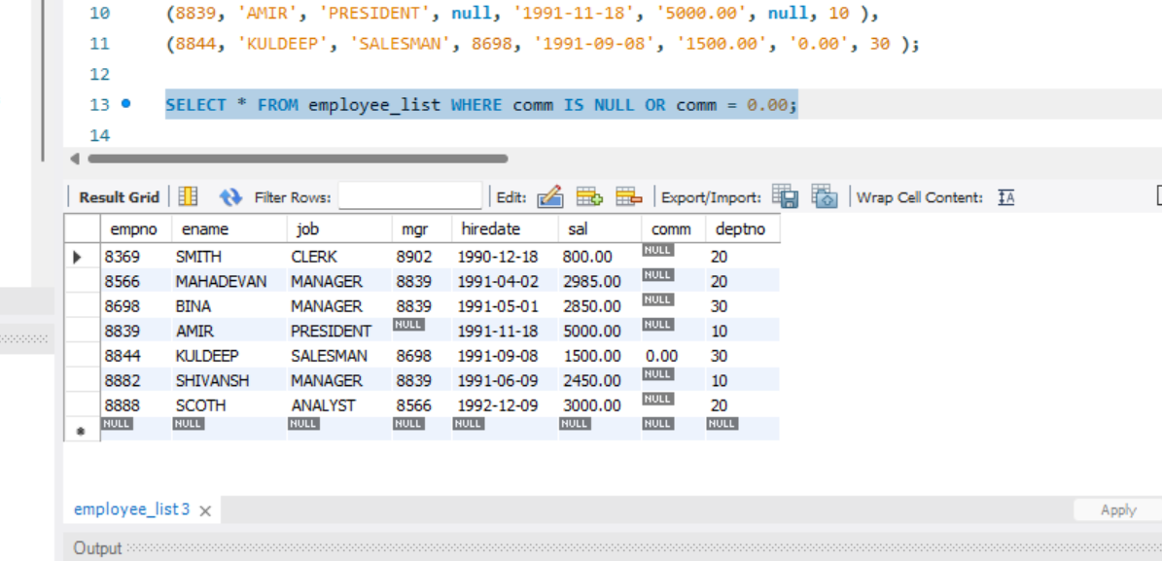

**Q1.C) Write a query to display employee name and salary of those employees who don’t have their salary in the range of 2500 to 4000:**

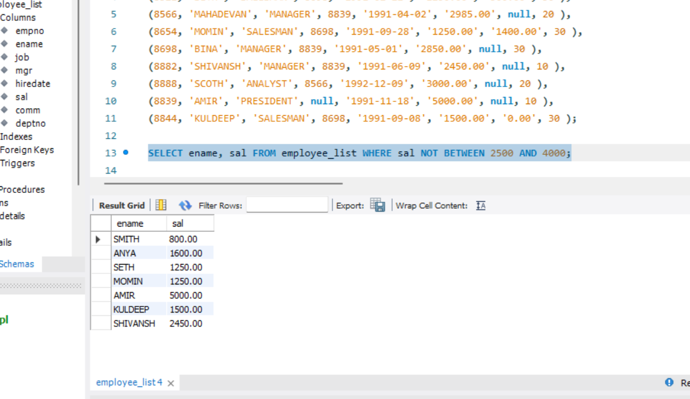

**Q1.D) Write a query to display name, Job title and salary of employees who don’t have a manager:**

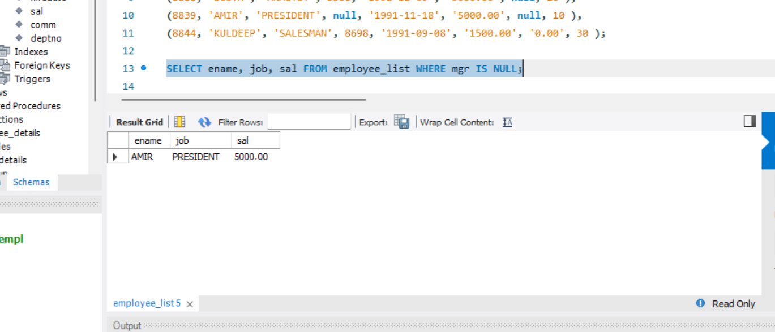

**Q1.E) Write a query to display the name of an employee whose name contains “A” as third alphabet:**

**No Name as the third alphabet with “A”.**

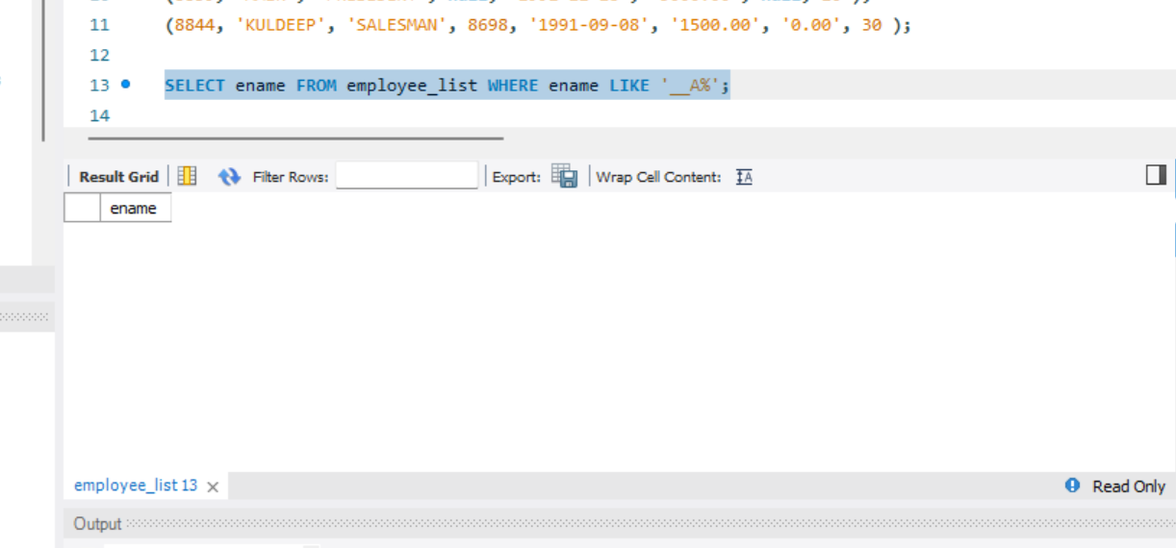

**Q1.F) Write a query to display the name of an employee whose name contains “T” as Last alphabet:**

**No Name ends with the alphabet “T”.**

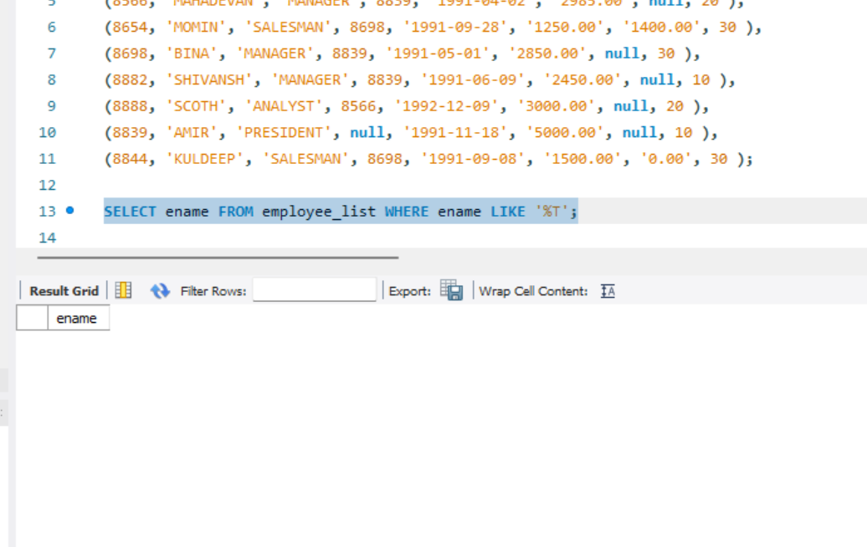

**Question:2**

